**FRAMBuilder**

**Program documentation & processing steps for preparing coded-wire tag data for Chinook FRAM base period calibration**

**The Chinook FRAM Base Period Workgroup, February 2016**

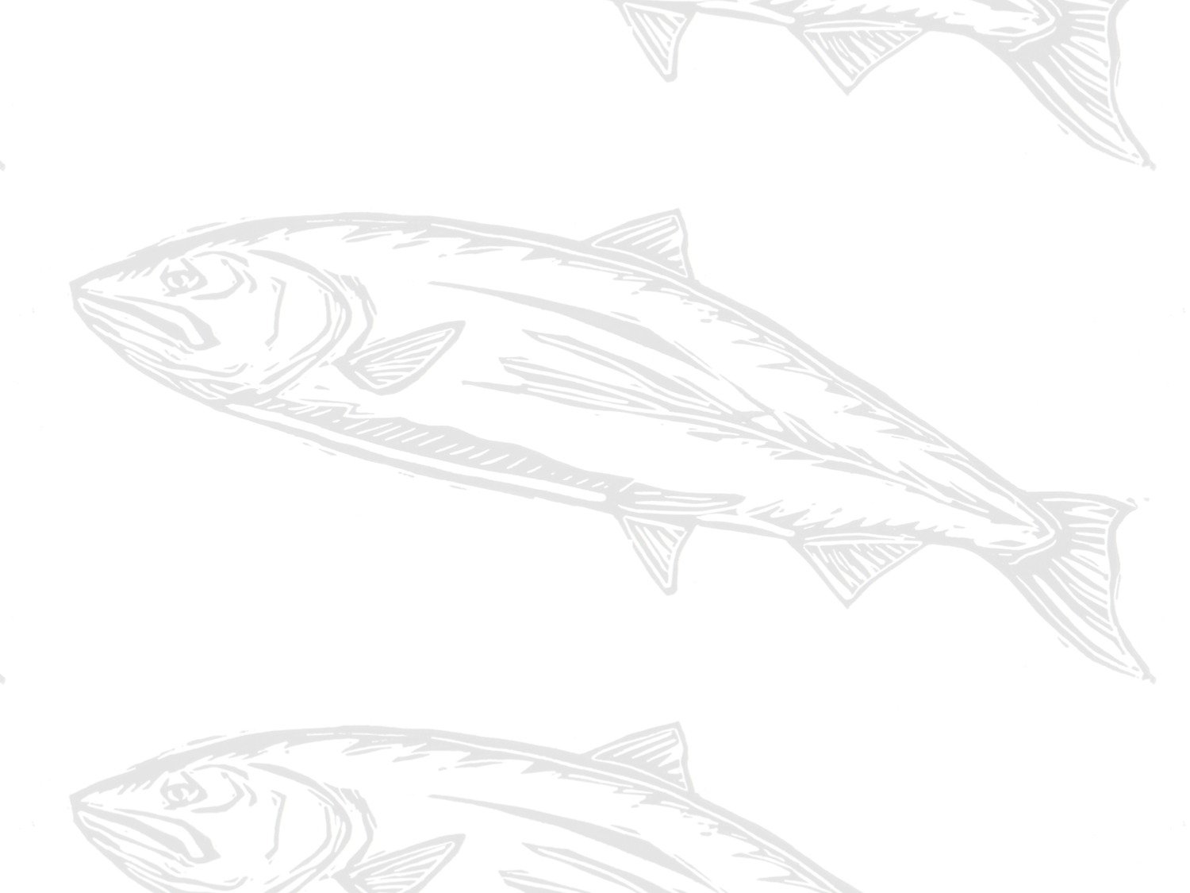

Contents

**1.** **Background and purpose** 3

**2.** **Overview of process (steps)** 4

**3.** **Required programs and data files** 4

**4.** **Step 1: Select tag groups** 5

**5.** **Step 2: Query RMIS for release/recovery data** 5

**6.** **Step 3: Filter RMIS data for importing to CAS** 5

**7.** **Step 4: Load filtered CWT data into CAS** 5

**8.** **Step 5: Run FRAMBuilder** 6

**9.** **Step 6: Export data** 6

**10.** **Other FRAMBuilder functions/features** 6

**11.** **Limitations to FRAMBuilder and opportunities for enhancement** 6

**Appendix A. Notes and exceptions for specific stock processing** 6

**Appendix B. Overview of the FRAM-modified CAS database** 6

1. **Background and purpose**

General purpose

Although the Regional Mark Processing Center’s (RMPC) Regional Mark Information System (RMIS) contains considerable information about the recovery of Chinook salmon with coded-wire tags (CWT), considerable processing must occur in order to translate this information into currency that’s meaningful within a FRAM base period calibration context. Firstly, individual tag groups must be associated with a specific FRAM model stock. Secondly, tags recovered at a particular location (indicated by RMIS location code), time, and using a particular gear, must be mapped to one of FRAM’s model fisheries and time steps. The FRAMBuilder program and workflow described here was developed to fulfill these needs, among others. For instance, the program, and companion FRAM-CAS database, was modified to facilitate the preparation of inputs for estimating the parameters of the von Bertalanffy growth functions used by FRAM.

The connection to CTC tools

Early in the development of FRAMBuilder and the overall CWT mapping workflow, the base period workgroup (BPW) identified distinct advantages/benefits to leveraging the Pacific Salmon Commission’s Chinook Technical Committee’s (CTC) CWT analysis tools (i.e., the Cohort Analysis System [CAS] mapping program and companion database) within a FRAM calibration context. The BPW ultimately decided to tie FRAMBuilder to the CTC world because this connection: (1) allows for the seamless integration of CTC ‘Auxiliary’ CWT files, agency-supplied/prepared files that supplement or correct known errors/gaps in RMIS’s CWT recovery information; (2) facilitates the efficient inclusion of screened/vetted CWT release groups (i.e., selected by CTC members with regional expertise) into the calibration database; and (3) increases the overlap in information driving models supporting the management decisions of the PSC, the Pacific Fishery Management Council (PFMC), and state–tribal co-managers. Additionally, given some overlap in the fishery assessment units used by the CTC and in FRAM, the integration of CAS into the FRAM calibration workflow offered efficiency in the form of an initial stage of RMIS-to-FRAM mapping.

Document scope

This user’s manual is meant to serve two purposes. Firstly, it provides a roadmap of the process that gets one from raw RMIS CWT release/recovery data to something useable in a FRAM calibration. Secondly, it provides basic documentation on the structure/function of the FRAMBuilder program, its companion FRAM-CAS database, and the ruleset it follows to get CWT recoveries from the initial CAS stage of mapping to a final FRAM fishery/time step state. As for the tools ‘borrowed’ from the CTC (i.e., CAS.exe), we provide only a brief sketch here and refer the reader to CTC resources for further documentation.

1. **Overview of the process**

In concept, the procedures to map an individual CWT recovery to a FRAM stock and fishery are straightforward: (a) in screening candidate codes, make a determination regarding which tags are suitable representatives for model stocks, and (2) given recovery details, such as RMIS location codes, gear codes, dates, etc., make a determination regarding the model fishery/time step to which the recovery belongs. In practice, however, this task is extremely difficult given that thousands of tag codes (= unique release groups) are available for consideration, resulting in hundreds of thousands of individual tag recoveries that must be mapped from one of tens of thousands of unique location-gear code combinations to one of FRAM’s seventy-two model fisheries. The FRAMBuilder workflow, although cumbersome at first glance, boils this seemingly insurmountable challenge down to a task that can be achieved by one person in a relatively short amount of time (i.e., assuming that candidate codes have been selected and auxiliary files have been acquired). It commences according to the following steps (Figure 1), each of which will be described in gory detail further below:

1. Select tag groups.
2. Query RMIS for release/recovery data.
3. Load RMIS query results into the CTC Filter database, and query it for CAS inputs.
4. Load tags into CAS (i.e., stage 1 of mapping – to CTC fishery strata).
5. Run FRAMBuilder (i.e., map/process recoveries).
6. Export data for calibration input files.

In addition to these steps, a handful of other functions can be invoked during step 5, depending on a user’s needs. These are also described further below. The remainder of this document is organized around each of these steps, where each subsection offers both ‘how to’ details and documentation on processing decisions, algorithms, etc. where necessary.

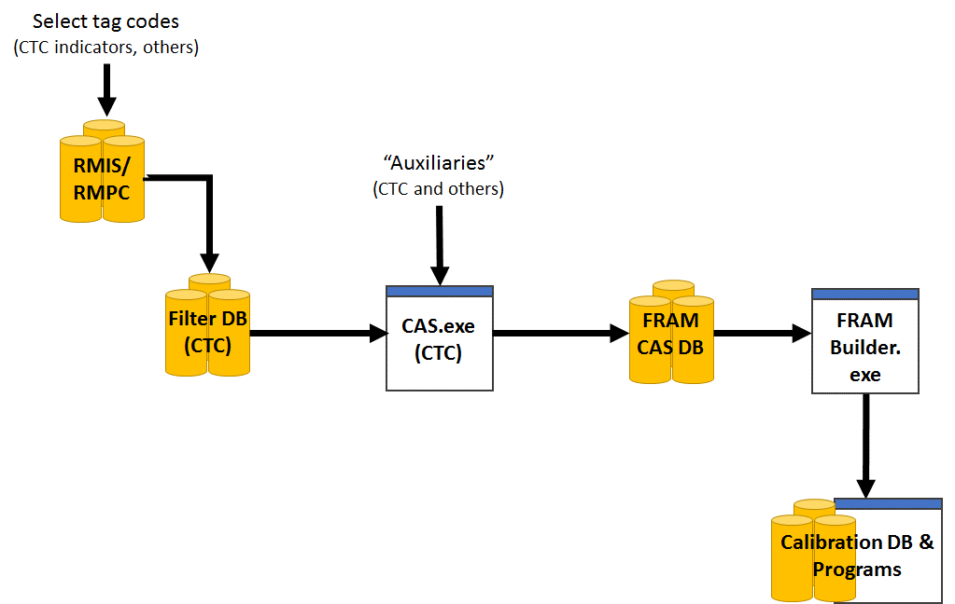

**Figure 1.** Relationships between the databases and programs used to construct FRAM base period calibration input files.

1. **Required programs and data files**

**Data Files**

* **A list of tag codes:** A list of tag codes is needed for the purposes of querying RMIS (release/recovery), as well as for populating the CTC Filter database’s ‘STKCDS’ table.
* **CWT release data**: These are the raw release details for the chosen codes, acquired from RMIS via a ‘Tagged Releases’ query; query results are downloaded as a CSV, with the headings specified under Step 2 below.
* **CWT recovery data**: These are the raw recovery details for the selected codes, acquired from RMIS via a ‘Recoveries By Tag Code’ query; query results are downloaded as a CSV, with the headings specified under Step 2 below.
* **Auxiliary files (or ‘auxiliaries’):** These are text files (*.csv or *.txt), prepared by CTC members from a variety of agencies/jurisdictions, that contain supplementary CWT recovery information that is meant to augment (or revise) the CWT information acquired from RMIS for some stocks; these files are typically created on a stock/code basis and are necessary to ensure the calibration process includes the most accurate information. For example, CWT recoveries in escapement—a major anchor point for the type of backwards cohort reconstruction underlying FRAM calibration—are not available via RMIS for many Canadian stocks.

**Databases (all Microsoft Access)**

* **The CTC’s Filter database:** This is a Microsoft Access database into which the RMIS release/recovery query results (above), combined with a tag list (‘STKCDS’) are loaded. Using two custom queries, this database returns RELEASES.txt and RECOVERIES.txt files which can be imported directly to the FRAM-CAS database.
* **A FRAM-modified CAS database (FRAM-CAS hereafter)**: This Access database is an adaptation of the CTC CAS database (final preseason 2013 version[1]), which includes several tables (and added fields to existing tables) designed to (1) cross-walk CTC fishery strata to FRAM fisheries or (2) to house/contain mapped outputs for direct export/use in CAS.

**Programs**

* **FRAMBuilder 2.0:** Because FRAMBuilder is very much an interactive program subject to ad hoc changes/revisions to fulfill the BP team’s evolving needs, it hasn’t yet been developed into a distributed, fully compiled .exe file (i.e., ‘production mode’). Thus, the ‘program’ is actually a Microsoft Visual Studio solution (.sln) file that is operated within the development environment (i.e., Visual Studio, version 2008+).
* **The CTC’s CAS (and dll)**: CAS1.5_No_Restrictions.exe and CASLib.dll (2013 versions)
* **Visual Studio, version 2008+**: To operate FRAMBuilder ‘in the environment’ you will need a compiler; Visual Studio Express for desktops is a good free option (if Professional isn’t on your list of programs).
* **Others**:Although they aren’t tied explicitly to the mapping procedures outlined here, there are both R and OpenBUGS programs that estimate parameters for growth functions from CWT length observations (i.e., mapped to FRAM fishery and size limit regulation) summarized by FRAMBuilder.

1. **Step 1: Select tag groups**

Although the rationale surrounding the final decisions to include/exclude tag codes is beyond the scope of this document, here we outline the basic guidelines we followed in selecting the codes contained in the current calibration dataset.

1. **Step 2: Query RMIS for release/recovery data**

This should include user-specified list…

1. **Step 3: Filter RMIS data for importing to CAS**

This should include user-specified list…

1. **Step 4: Load filtered CWT data into CAS**

Sketch process, refer reader to CAS specs, etc. Troubleshooting BADs; cover auxiliaries as a sub-heading…including preparation of special ones (e.g., Jon’s, LCN, etc.)

1. **Step 5: Run FRAMBuilder**

Here, cover the options, etc…describe the mapping rules, age assignments, time step assignments, etc. WEIGHTING!!!! Process Log output warnings…

1. **Step 6: Export data**

Sketch process, refer reader to CAS specs, etc. Troubleshooting

1. **Other FRAMBuilder functions/features**

Preparing data for analyzing growth…

1. **Limitations to FRAMBuilder and opportunities for enhancement**

Sketch process, refer reader to CAS specs, etc. Troubleshooting

**Appendix A. Notes and exceptions for specific stock processing**

e.g., ageing up by one year Willamette and CKL spring Chinook…origin is in the old FRAMBuilder program (Kurt Reidinger)

**Appendix B. Overview of the FRAM-modified CAS database**

Sketch process, refer reader to CAS specs, etc. Troubleshooting

1. The FRAM-CAS fishery crosswalk adheres strictly to the CTC’s ‘fine scale’ fishery strata from 2013; any attempt to create an updated FRAM-CAS database will require an updated FRAM to CTC crosswalk (database table ‘FRAM_Fishery’.